GITAM

(DEEMED TO BE UNIVERSITY)

**TITLE**:PCB WORKSHOP

**SUB TITLE :** ANALOG AND DIGITAL

ECE DEPARTMENT

**TEAM MEMBERS** :

VENKATA TEJA (BU21EECE0100106)

KJ SAGAR (BU21EECE0100162)

**PCB WORKSHOP**

**Digital Circuit**

**Simulation Results for Low Pass Filter:**

**Components Required:**

1. Breadboard
2. Capacitors
3. Resistors
4. LED
5. Power Supply
6. AND Gate IC – 74HC08
7. XOR Gate IC – 74HC86
8. DIP Switch SPST X 4

**Circuit Diagram:**

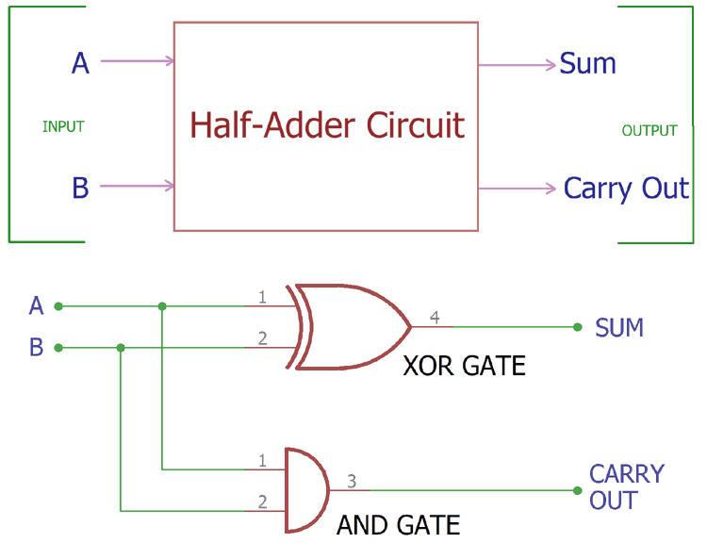

**Procedure:**

• **Place the Breadboard**: Drag and drop a breadboard onto the workspace.

• **Place the ICs**: Drag the 7408 (AND gate) and 7486 (XOR gate) ICs onto the breadboard, ensuring they are positioned across the central divider.

• **Connect Power and Ground**:

* Connect the VCC (pin 14) of both ICs to the positive power rail.
* Connect the GND (pin 7) of both ICs to the ground rail.

•**Setting up the DIP Switch SPST X 4**:

* Connect the 1A and 2A to the positive VCC.
* Connect the 1B and 2B are the common inputs for the gates.

• **Connecting the XOR Gate (7486) for the Sum**:

* Connect the first input of the XOR gate (pin 1) to the 1B (A input).
* Connect the second input of the XOR gate (pin 2) to the 2B (B input).
* The output of the XOR gate (pin 3) will be the Sum output.

• **Connecting the AND Gate (7408) for the Carry**:

* Connect the first input of the AND gate (pin 1) to the 1B (A input).
* Connect the second input of the AND gate (pin 2) to the 2B (B input).
* The output of the AND gate (pin 3) will be the Carry output.

• **Connecting LEDs**:

* Place two LEDs on the breadboard.
* Connect a 150 Ohm resistor to the anode (long leg) of each LED.
* Connect the resistor of the first LED to the Sum output (pin 3 of the XOR gate).
* Connect the resistor of the second LED to the Carry output (pin 3 of the AND gate).
* Connect the cathodes (short leg) of both LEDs to the ground rail.

# • **Final Connections**:

* Ensure all components are properly connected.
* Connect the power supply to the breadboard.

**Hardware Implementation:**

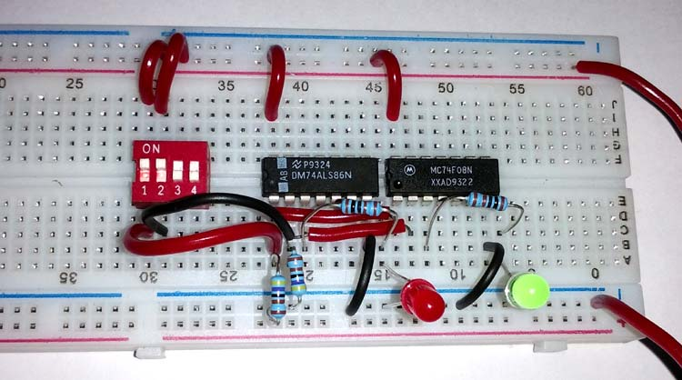

# **Circuit Schematic in TINKERCAD:**

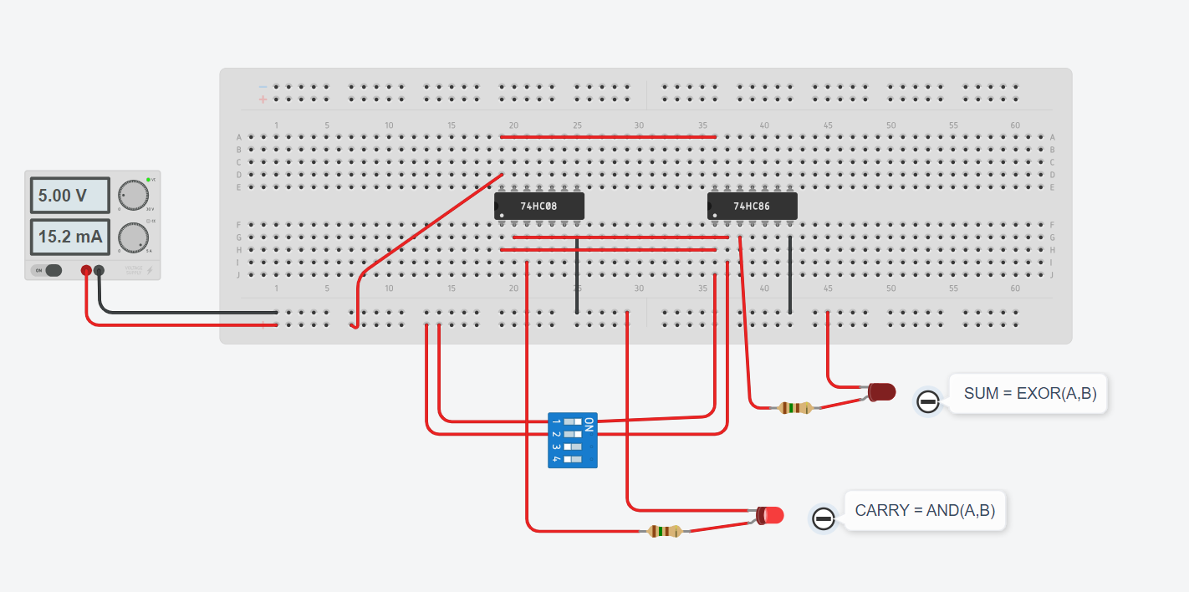

# **Simulation in Easy Eda:**

• **Create a New Project:**

* Open Easy EDA.
* Click on "New Project" and give it a name, like "Half Adder Design."

• **Add Components:**

* You need two logic gates: an XOR gate and an AND gate.
* In the components library, search for "XOR gate" and "AND gate."
* Drag and drop one XOR gate and one AND gate onto your schematic canvas.

• **Add Input and Output Ports:**

* You need two input ports (A and B) and two output ports (Sum and Carry).
* Search for "Input" in the components library and add two input ports.
* Search for "Output" in the components library and add two output ports.

• **Wire the Components:**

* Connect one input port (A) to one input of both the XOR gate and the AND gate.
* Connect the second input port (B) to the other input of both the XOR gate and the AND gate.
* Connect the output of the XOR gate to one output port labelled "Sum."
* Connect the output of the AND gate to the other output port labelled "Carry."

• **Label the Ports:**

* Right-click on each input and output port to rename them as A, B, Sum, and Carry.

• **Check and Save:**

* Check your connections to ensure everything is wired correctly.
* Save your schematic.

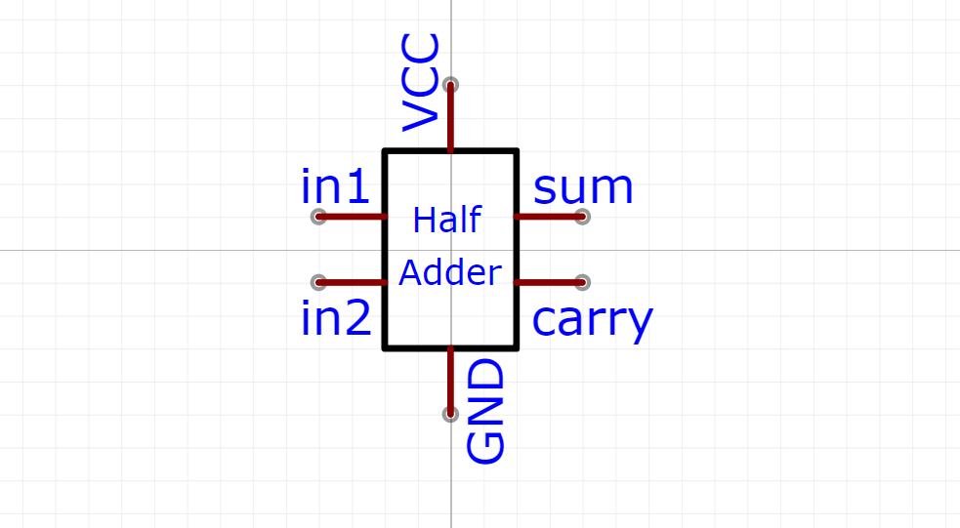

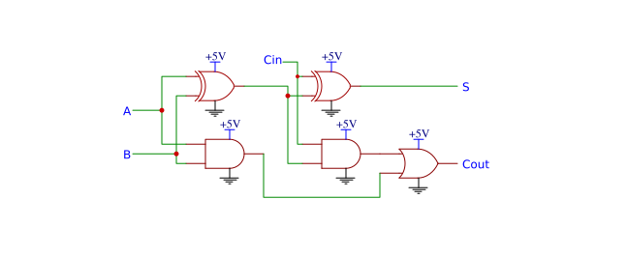

**Conclusion:**

To conclude the analysis of a half adder using Tinker cad and Easyeda, we can summarize the findings from both tools. The half adder is a fundamental digital circuit used to perform binary addition, consisting of two inputs (A and B) and two outputs (Sum and Carry). Here's a concise conclusion based on simulations and designs in both platforms.

**Analog Circuit**

Components Required:

1.Bread board-1

2.Capacitors

3.Resistors

4.Op-amp

5.Power Supply

6.Connecting Wires

7.CRO 20/30Mhz

8.Probes

CIRCUIT DIAGRAM:

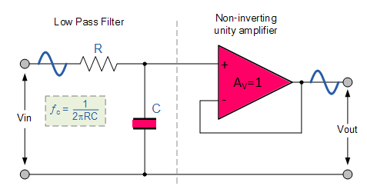

Procedure:

1. **Prepare Breadboard:**
   * Place the breadboard on a stable surface.
2. **Insert Components:**
   * Insert capacitors and resistors into the breadboard as per the circuit diagram.
3. **Integrate Op-Amp:**
   * Insert the op-amp into the breadboard according to the circuit layout.
4. **Wire Power Supply:**
   * Connect the positive and negative terminals of the power supply to the breadboard's power rails.
5. **Connect Components:**
   * Use connecting wires to establish connections between the components based on the circuit diagram.
6. **Power On:**
   * Turn on the power supply to provide power to the circuit.
7. **CRO Setup:**
   * Set up the CRO (20/30MHz) by connecting its probes to the appropriate terminals of the circuit.
8. **Signal Analysis:**
   * Use the CRO to analyze the signals in the circuit, observing waveform characteristics and frequencies.
9. **Probe Placement:**
   * Attach probes to specific points in the circuit to measure voltage levels and signal waveforms accurately.

Hardware Implementation:

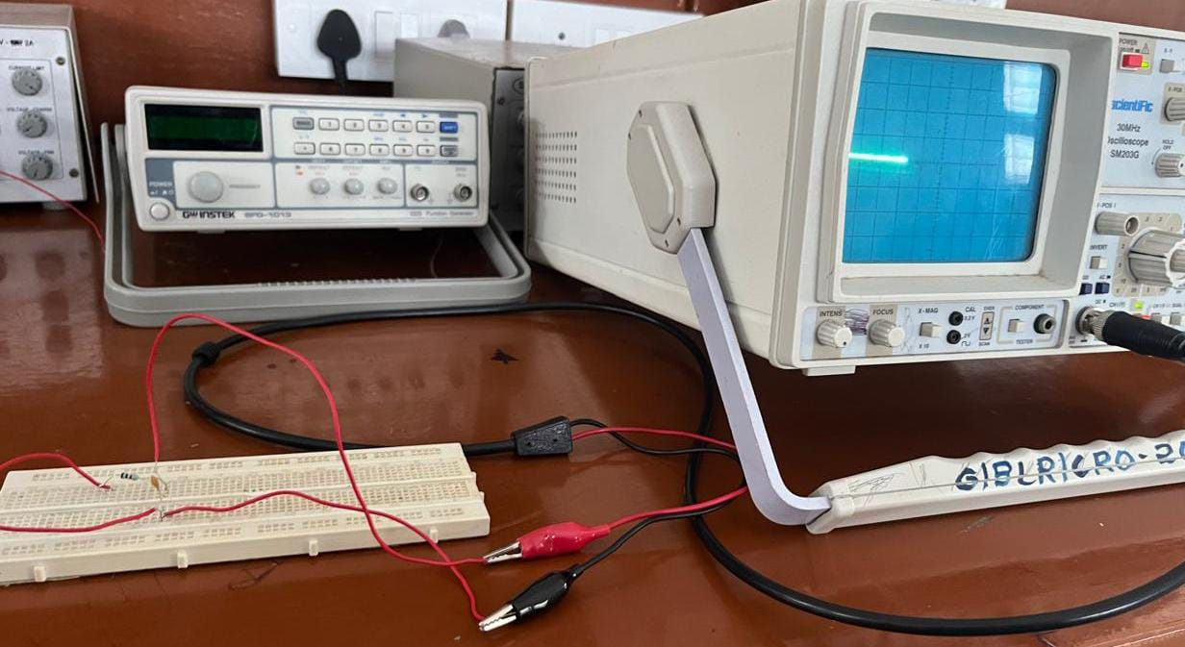

Circuit Schematic in Tinkercad:

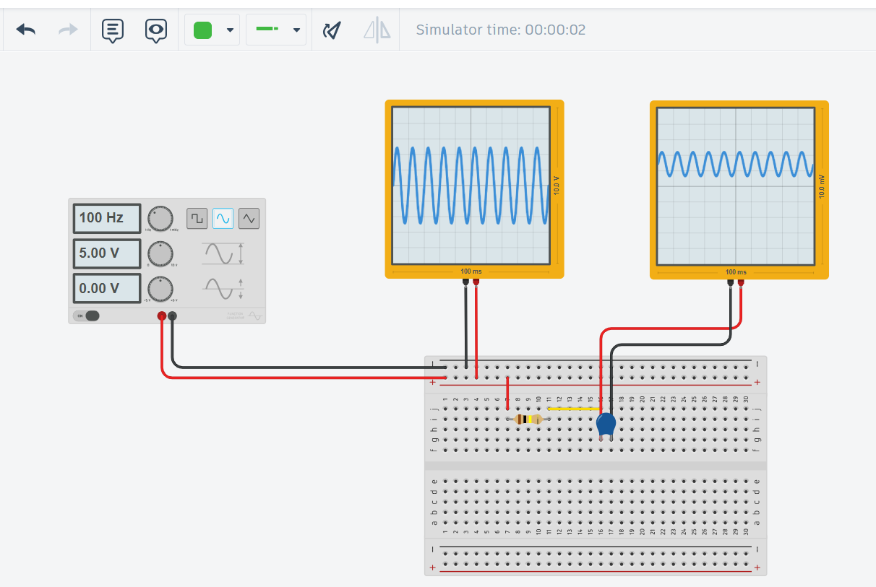

Simulation in Easy Eda:

**Open EasyEDA:** Go to the EasyEDA website and log in.

**Create New Project:** Click "New Project" and name it.

**Open Schematic:** Click "New Schematic" to start.

**Add Resistor:** Search for "Resistor" in the "Libraries" tab and place it on the schematic.

**Add Capacitor:** Search for "Capacitor" in the "Libraries" tab and place it.

**Add Ground:** Search for "GND" and place it.

**Add Voltage Source:** Search for "VSource" and place it.

**Connect Components:** Wire the resistor to the capacitor, the voltage source to the resistor, and ground the capacitor and voltage source.

**Set Values:** Double-click the resistor (set to 1kΩ) and the capacitor (set to 1µF).

**Run Simulation:** Click "Simulate," choose "AC Analysis," set frequency range (10Hz to 1MHz), and run.

**View Results:** Check the frequency response plot to see the filter's performance.

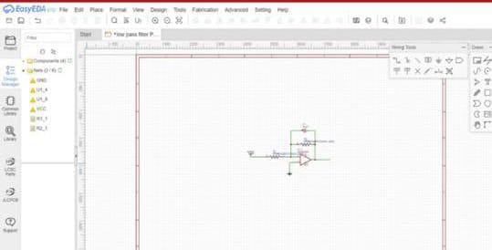

2D View:

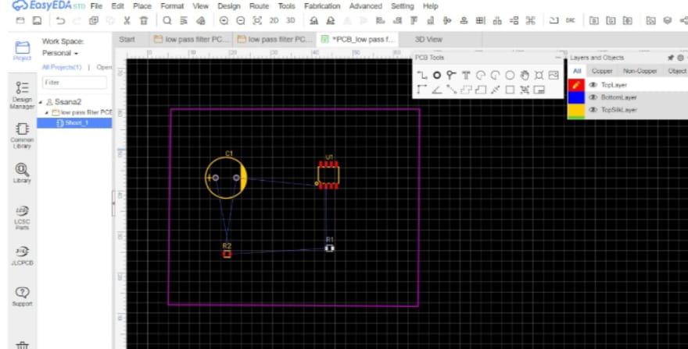

3D View:

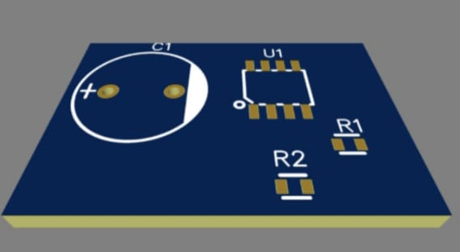

**Conclusion:**

To conclude the analysis of a half adder using Tinkercad and EasyEDA, we summarize the findings from both tools. The half adder is a fundamental digital circuit used to perform binary addition, consisting of two inputs (A and B) and two outputs (Sum and Carry). The simulations and designs in both platforms demonstrate the accurate functionality and efficiency of the half adder.